Umuzi Database.
Documentation.



1

Nhlalwenhle W.G Gumede
13 June 2019.

Table of Contents

- Introduction 3
- Overview 3
- Database Management System (DBMS) 3
- DBMS USED MySQL 4
- MySQl VERSION 4
- Schema 4
- Umuzi Database Diagram. 5
- Foreign Key Rlationship Diagram. 6
- Creating the umuzi database. 7
- Tables. 9
- Inserting Database Data. 12
- Reference 14

Introduction.

This document describes the Umuzi database .
The Umuzi database was developed by Nhlalwenhle W.G Gumede and provides a combination of relatively small base of data (approximately 9.9kb’s) spread over five separate tables and consisting of 16 records in total. The data was compiled using an InnoDB Engine.

Overview.

A database is a means of storing information in such a way that information can be retrieved from it. In simplest terms, a relational database is one that presents information in tables with rows and columns that have some form of relation to one another be it through a foreign key etc.

Database Management System (DBMS)

A database management system (DBMS) is system software for creating and managing databases. The DBMS provides users and programmers with a systematic way to create, retrieve, update and manage data.A DBMS makes it possible for end users to create, read, update and delete data in a database. The DBMS essentially serves as an interface between the database and end users or application programs, ensuring that data is consistently organized and remains easily accessible. [1]

DBMS USED MySQL .

MySQL is free and open-source software under the terms of the GNU General Public License, and is also available under a variety of proprietary licenses. MySQL was owned and sponsored by the Swedish company MySQL AB, which was bought by Sun Microsystems (now Oracle Corporation). [2]

MySQl VERSION

To install the MySQL version of the Umuzi database, you must have MySQL installed. See mysql.com for instructions.
This Database was was created on Linux Ubuntu 19.04 Terminal and a MysSQL Workbench for the model visualization.

SCHEMA.

This Database consists of Five tables:
- Customers: List of customers.
- Employees: All employees in the company.
- Orders: Orders placed by customers.
- Products: Table of all products sold by company.
- Payments: Payments are made by customer against their accounts.

Umuzi Database Diagram.

This diagram shows the table structure and relationships.
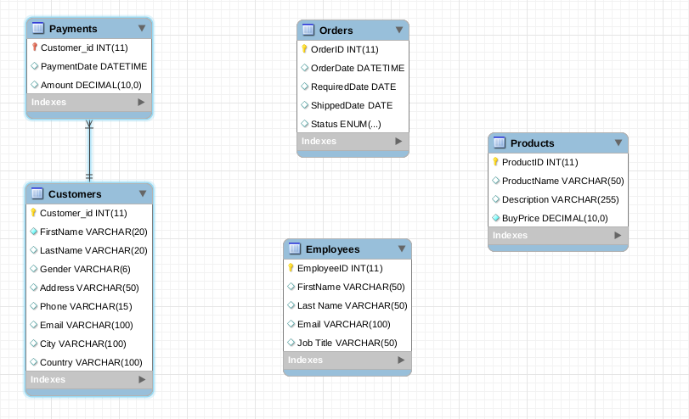

Foreign Key Rlationship Diagram.

Here is the relationship between those tables: Customers and Payments.
Foreign key = Customer_id.

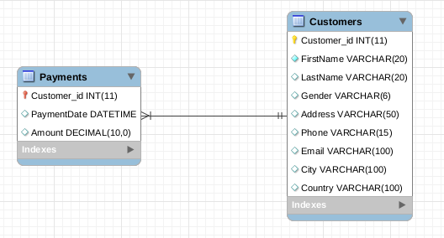

Creating the umuzi database.

SHOW CREATE DATABASE Umuzi;
| Umuzi | CREATE DATABASE `Umuzi` /*!40100 DEFAULT CHARACTER SET latin1 */ /*!80016 DEFAULT ENCRYPTION='N' */ |

SHOW CREATE TABLE Customers;

Customers | CREATE TABLE `Customers` (
`Customer_id` int(11) NOT NULL AUTO_INCREMENT,
`FirstName` varchar(20) NOT NULL,
`LastName` varchar(20) DEFAULT NULL,
`Gender` varchar(6) DEFAULT NULL,
`Address` varchar(50) DEFAULT NULL,
`Phone` varchar(15) DEFAULT NULL,
`Email` varchar(100) DEFAULT NULL,
`City` varchar(100) DEFAULT NULL,
`Country` varchar(100) DEFAULT NULL,
PRIMARY KEY (`Customer_id`)
) ENGINE=InnoDB AUTO_INCREMENT=6 DEFAULT CHARSET=latin1

SHOW CREATE TABLE Employees;

Employees | CREATE TABLE `Employees` (
`EmployeeID` int(11) NOT NULL AUTO_INCREMENT,
`FirstName` varchar(50) DEFAULT NULL,
`Last Name` varchar(50) DEFAULT NULL,
`Email` varchar(100) DEFAULT NULL,
`Job Title` varchar(50) DEFAULT NULL,
PRIMARY KEY (`EmployeeID`)
) ENGINE=InnoDB AUTO_INCREMENT=4 DEFAULT CHARSET=latin1

SHOW CREATE TABLE Orders;

Orders | CREATE TABLE `Orders` (
`OrderID` int(11) NOT NULL AUTO_INCREMENT,
`OrderDate` datetime DEFAULT NULL,
`RequiredDate` date DEFAULT NULL,
`ShippedDate` date DEFAULT NULL,
`Status` varchar(15) DEFAULT NULL,
PRIMARY KEY (`OrderID`)
) ENGINE=InnoDB AUTO_INCREMENT=4 DEFAULT CHARSET=latin1

SHOW CREATE TABLE Payments;

Payments | CREATE TABLE `Payments` (
`Customer_id` int(11) NOT NULL AUTO_INCREMENT,
`PaymentDate` datetime DEFAULT NULL,
`Amount` decimal(10,0) DEFAULT NULL,
PRIMARY KEY (`Customer_id`),
CONSTRAINT `Payments_ibfk_1` FOREIGN KEY (`Customer_id`) REFERENCES `Customers` (`Customer_id`)
) ENGINE=InnoDB AUTO_INCREMENT=3 DEFAULT CHARSET=latin1

SHOW CREATE TABLE Products;

Products | CREATE TABLE `Products` (
`ProductID` int(11) NOT NULL AUTO_INCREMENT,
`ProductName` varchar(50) DEFAULT NULL,
`Description` varchar(255) DEFAULT NULL,
`BuyPrice` decimal(10,0) NOT NULL,
PRIMARY KEY (`ProductID`)
) ENGINE=InnoDB AUTO_INCREMENT=4 DEFAULT CHARSET=latin1

Tables.
Table: Payments.
Table holds customer id’s, amounts payment date of all received from customers in the past, present and future.
Payments
COLUMN | DATA TYPE | DESCRIPTION
Customer_id | int | Primary key for Payments records. Foreign key to Customer table via the customer_id.
PaymentDate | datetime | Date of the payment transaction being processed.
Amount | Decimal(10.0) | Value/Amount paid in Rands ®.

Table: Products.
Table holds all products held by the company including each products id, the product name, description and price that the product.

Products
COLUMN | DATA TYPE | DESCRIPTION
ProductID | INT
ProductName | VARCHAR(15)
Description | VARCHAR(15)
BuyPrice | Decimal(10.0)

Table: Orders.
Table holds all orders made by customers, it details the order date and the date that the ordered item is required on.
Orders
COLUMN | DATA TYPE | DESCRIPTION
Order_id | INT
Order Date | datetime
Required Date | Date
Shipped Date | Date
Status | VARCHAR(15)

Table: Employees.
Table holds all past, current and future employees of the company.
Employees
COLUMN | DATA TYPE | DESCRIPTION
EmployeeID | INT
FirstName | VARCHAR(50)
Last Name | VARCHAR(50)
Email | VARCHAR(100)
Job Title | VARCHAR(50)

Table: Customers
Table holds customer details from customers in the past, present and future.
Customers Table
COLUMN | DATA TYPE | DESCRIPTION
Customer_id | INT
FirstName | VARCHAR(20)
LastName | VARCHAR(20)
Gender | VARCHAR(6)
Address | VARCHAR(50)
Phone` | VARCHAR(15)
Email | VARCHAR(100)
City | VARCHAR(100)
Country | VARCHAR(100)

Relations

Table | Role | Foreign Key Column | Description
Customers |  | Customer_id
Payments |  | Customer_id

List of Values.
Column | Description
Status | enum('SHIPPED','NOTSHIPPED') DEFAULT 'NOTSHIPPED'

Inserting Database Data.

--Insert into customers table.

INSERT INTO Customers VALUES (3 'Leon', 'Glen', 'Male', '81 Everton Rd,Gillits', '0820832830, 'Leon@gmail.com', 'Durban', 'South Africa');

INSERT INTO Customers VALUES (2, 'Thando', 'Sithole', 'Female', '240 Sect 1', '0794445584', 'thando@gmail.com', 'Cape town', 'South Africa');

INSERT INTO Customers VALUES (3, 'Leon', 'Glen', 'Male', '81 Everton Rd, Gillits', '0820832830', 'Leon@gmail.com', 'Durban', 'South Africa');

INSERT INTO Customers VALUES (4, 'Charl', 'Muller', 'Male', '290A Dorset Ecke', '+44856872553', 'Charl.muller@yahoo.com', 'Berlin', 'Germany');

INSERT INTO Customers VALUES (5, 'Julia', 'Stein', 'Female', '2 Wernerring', '+448672445058', 'Js234@yahoo.com', 'Frankfurt', 'Germany');

--code used to view contents of table
SELECT* FROM Customers;

--Insert into Employees table.

INSERT INTO Employees VALUES (1, 'Kani', 'Matthew', 'mat@gmail.com', 'Manager');

INSERT INTO Employees VALUES (2, 'Lesly', 'Cronje', 'LesC@gmail.com', 'Clerk');

INSERT INTO Employees VALUES (3, 'Gideon', 'Maduku', 'm@gmail.com', 'Accountant');

--code used to view contents of table
SELECT* FROM Employees;

--Insert data into orders

INSERT INTO Orders VALUES ('1', '2018-09-01 ', '2018-09-05', '2018-09-02', 'Not shipped');

INSERT INTO Orders VALUES ('2', '2018-09-01 ', '2018-09-04', '2018-09-03', 'Shipped');
INSERT INTO Orders VALUES ('3', '2018-09-01 ', '2018-09-03', '2018-09-02', 'Not shipped');

--code used to view contents of table
SELECT* FROM Orders;

--Inserting data into products

INSERT INTO Products VALUES ('1', 'Harley Davidson Chopper ', 'This replica features working kickstand, front suspension, gear-shift lever', '151');

INSERT INTO Products VALUES ('2', ' Classic Car', 'Turnable front wheels, steering function', '551');

INSERT INTO Products VALUES ('3', ' Sports Car', 'Turnable front wheels, steering function', '701');

--code used to view contents of table
SELECT* FROM Products;

--Inserting data into Payments.

INSERT INTO Payments VALUES ('1', ' 2018-09-01', '100');

INSERT INTO Payments VALUES ('2', ' 2018-09-01', '251');

--code used to view contents of table
SELECT* FROM Payments;

Reference:

- DBMS https://searchsqlserver.techtarget.com/definition/database-management-system
- DBMS used: MySQL - https://en.wikipedia.org/wiki/MySQL

